**EAP**

##### Educators’ Employee Assistance Plan

Educator’s EAP is a sevice that provides benefits and solutions to you and your family with any personal issue. In addition, this service provides resources to deal with professional issues and the unique challenges educators face. **The cost of these services are covered by Monroe One-there is no cost to you and it is confidential.**

To access the website, go to:

<http://www.theeap.com>

Select EMPLOYEE-LOGIN:

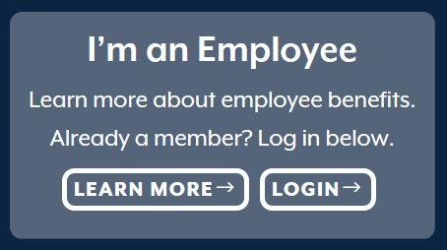

Register as a member:

