BROCCOLI WITH CHEESE SAUCE
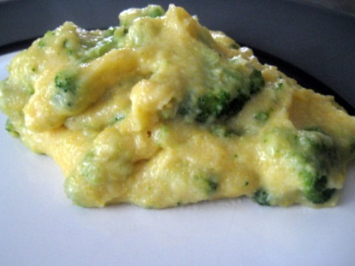
1 lb. broccoli
2 tbsp. butter
2 tbsp. flour
1 c. milk
1/4 tsp. salt
1/8 tsp. pepper
1/4 lb. Velveeta cheese

Directions:

Broccoli
Wash broccoli and cut into small bite size pieces.
Place small amount of water in pan and bring to boil, put broccoli in pan, bring to boil, reduce heat, cook on medium heat for 5-10 minutes until broccoli is tender.

Cheese Sauce

- Melt butter over low heat.
- Add flour, salt and pepper. Mix well.
- Add milk and cook, stirring constantly until mixture thickens.
- To this mixture, add cheese, cut into small pieces.
- Return on stove and heat again, stirring constantly until cheese is melted.
- Pour over drained broccoli and serve immediately.

