Meatloaf

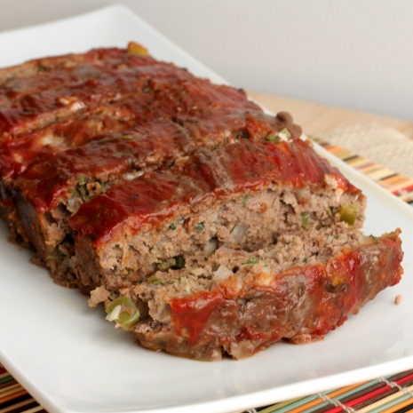Ingredients

2 pounds ground beef

2 eggs

3/4 cup ketchup

1 cup dried bread crumbs

¼ tsp salt

¼ tsp pepper

1 package onion soup mix

Directions

1. Preheat oven to 350.
2. In a large bowl place ground beef
3. Add eggs, ketchup, bread crumbs, salt, pepper and onion soup mix
4. Mix together until well blended
5. Form into a loaf and place in pan.
6. Brush top of meatloaf with ketchup
7. Bake for 1 hour