**Approvers and Reviewers 6.20.19**

**CompanyMileage Overview:**

**Log On:** Url: https.//login.companymileage.com Use Edge or Chrome as browser

**User Name:** First Name_Last Name@boces.monroe.edu (Per Wincap HR) (Username is NOT case sensitive)

**Password:** Welcome1 (Password is CASE SENSITIVE) then reset password. (New Password must contain at least 6 characters with at least one number or symbol, caps are not necessary, but again, the Password is CASE SENSITIVE). If you get locked out, (after 5 tries, then email us.)

**Auto Password reset every 180days.**

* My Profile Settings: Click on My Profile settings to:
* Validate Work and home address: (You may have done this when you went through User Training)
* SureMobile App for your phone is available and automatically transfers data into CM.

**Approvers:** Dept Clerical/Admin, 1st level of approval, ensures entries are correct, can approve, edit, reject trips.

**Reviewers:** Administrators, 2nd level of approval, can override 1st level.

**Misc/Benefits of using Company Mileage:**

CM uses MapQuest and then defaults to Google and calculates the Shortest route. Mileage Rules have not changed. Just as before, if staff choose to go the fastest route and incur additional miles, they will not be paid for those miles.

* **Begin entering as of JULY 1 or the date of your first trip**
* Current Rate for 2019 is .58:
* Transportation will notify Business Office of School Closings (snow days, etc.)
* Save as you go, using back arrow will show Leave/Stay on Page, if you leave page, you will get booted out.
* No more printing of maps
* Staff can enter all scheduled locations to their Personal Addresses, see page 5 of your User Guidelines
* Full User Basic Manual, Approver/Reviewer Manual and Video Tutorials are available and are accessible from Dashboard/Support.
* CM system does NOT like the enter key or the back arrow on your browser, use your tab key or click your curser in field for ease of use.
* If staff changes: dept/position or bank account, we MUST be informed. THEY WILL NOT GET PAID if we do not know about bank changes.

As Approvers/Reviewers, Your **Dashboard** will have 2 sets of data, your **Group** and your **Personal**:

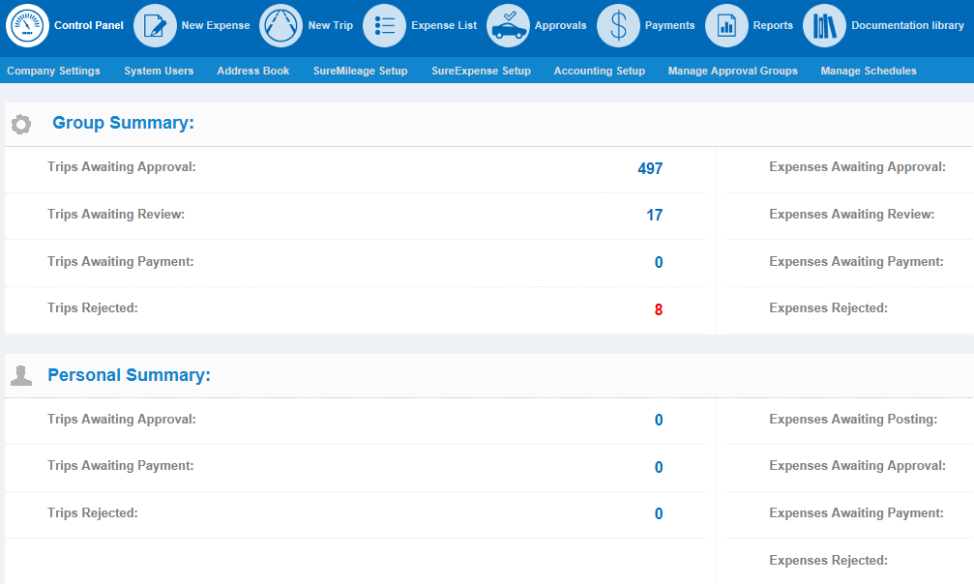

To view Employee Trips to Approve: click on **Trips Awaiting Approval:**

Here you can view the trips entered and waiting for approval:

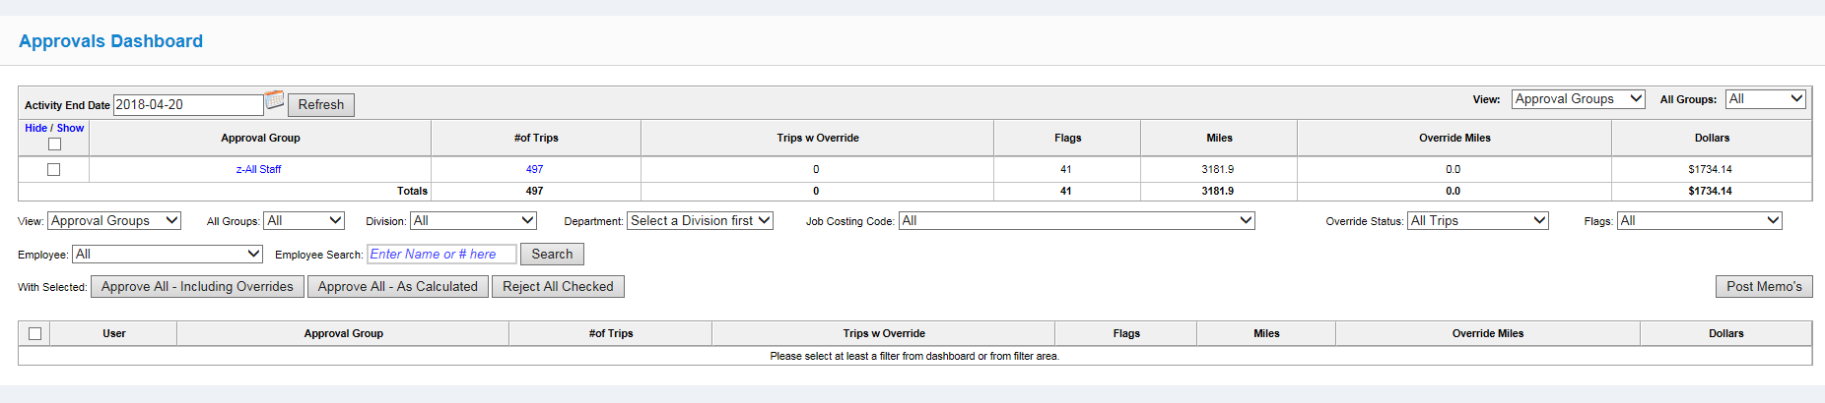

Select an Activity End Date (month end date). In the Approval Group field, click on **z-All Staff**: you can see all Employees that entered trips

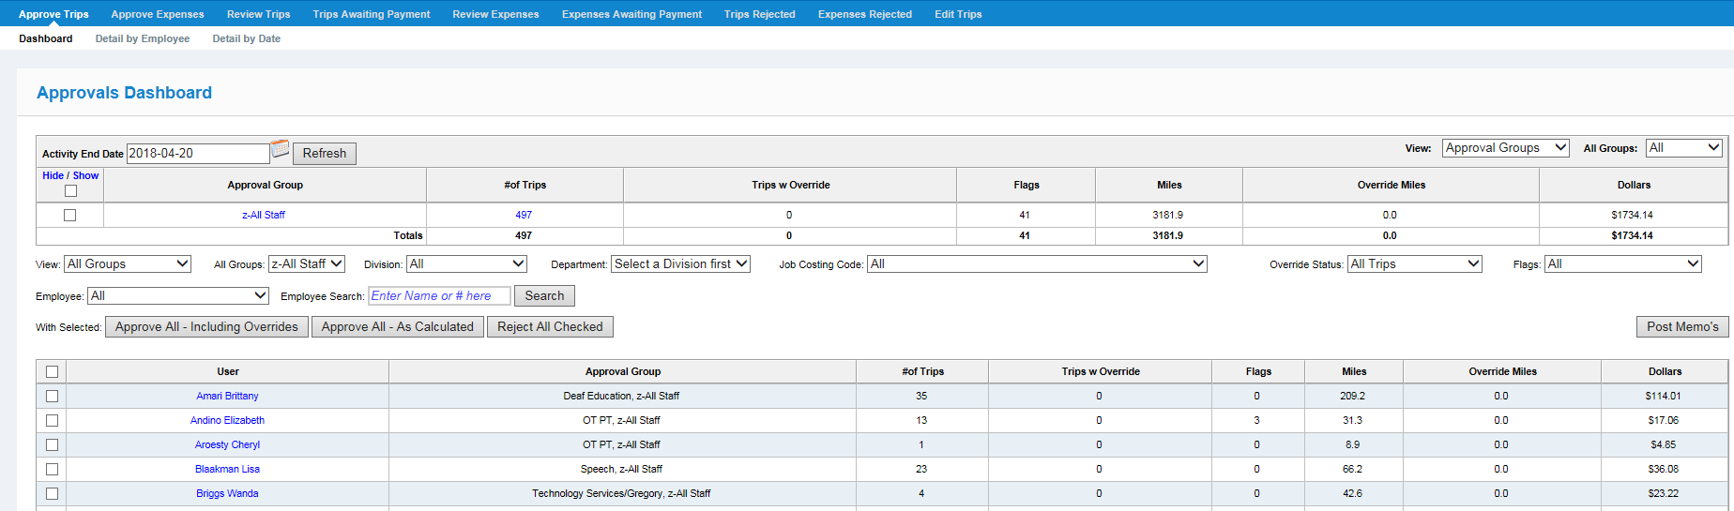

Click on User’s name and the details of the trip are visible. You would use this to verify trip information such as date, route and miles.

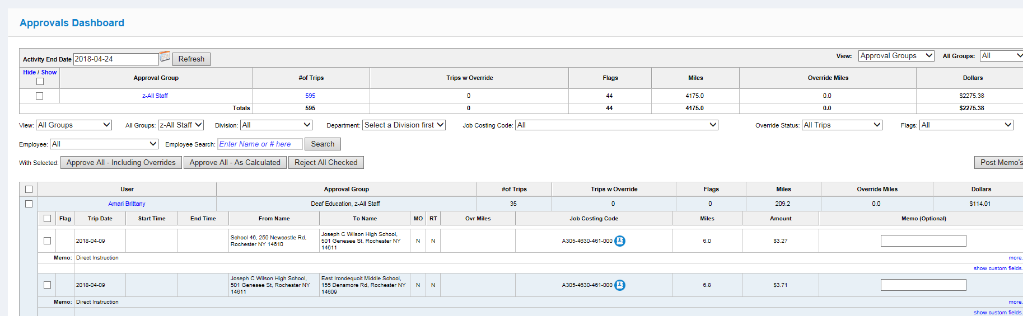

To see MORE details, click on the “more” hyperlink to the very bottom right of the trip and additional information will become available:

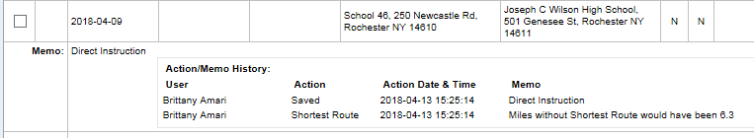

**Click on Show Custom Fields to view the PURPOSE of the trip, which is now a MUST enter field. Staff do not need to put note in Memo field**.

If you agree with ALL the trips the employee has made, simply click on the box in the upper left hand corner, the detail collapses, and place a check in the box:

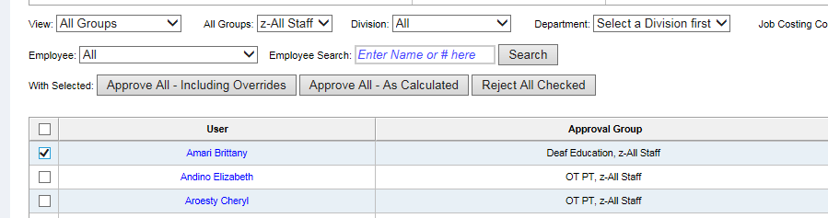

Go on to the next employee, etc. If All are ok, you can then click on Approve all – as calculated. This action sends your approved trips to the next level, the Reviewer. **IF there are trips that have Mileage Overrides, you MUST select Approve All –Including Overrides.**

If you DISAGREE with a trip, you can REJECT it. You MUST put a note in the memo field. Once you Reject it, the system sends an email to the employee’s Outlook account stating that there is a Rejected Trip that need attention. They can then add additional information and Resubmit.

ONCE A TRIP IS REJECTED, IT **MUST** GO THROUGH THE FULL CYCLE AGAIN: User/Approver/Reviewer.

**REVIEWERS: FOLLOW THE SAME PROCESS AS THE APPROVERS. ONCE YOU APPROVE, TRIPS WILL AUTOMATICALLY BE SENT TO “TRIPS AWAITING PAYMENT”.**

REPORTS:

From Your Dashboard: Click on Reports



To get a detailed report for YOUR Dept/employees, select Detail Report by Date Range

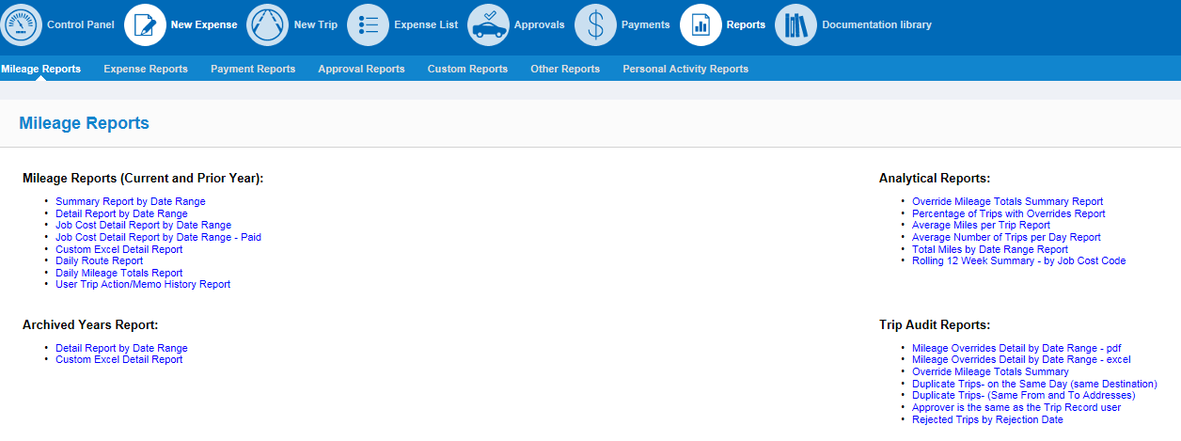

Detail Report by Date Range: Input Trip Date From and To, Division (Always Monroe #1) and Dept ( I chose OT/PT as example), then click Generate

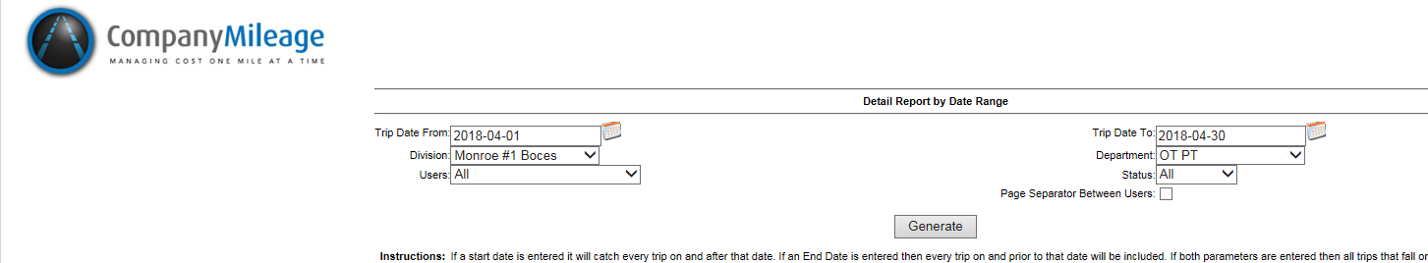

The report lists employees, in order with their daily trips, NO Detail is in this report

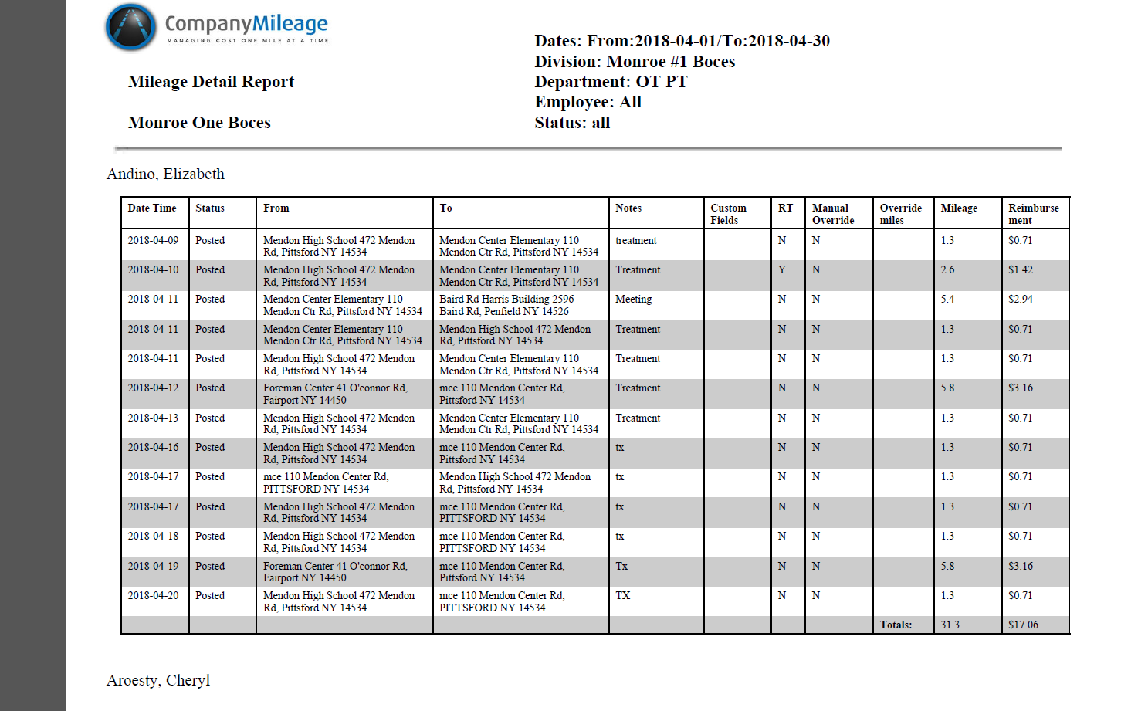

**REIMBURSEMENTS: *****IMPORTANT: WE USE AN OVERNIGHT FILE FEED. NEW EMPLOYEES, DEPENDING ON DEPT, MAY BE UPLOADED AUTOMATICALLY. TELL ALL EMPLOYEES TO CONTACT BOCES MILEAGE HELP BEFORE TRYING TO ACCESS THE SYSTEM. WE NEED TO CONFIRM THEY HAVE DIRECT DEPOSIT BEFORE THEY ENTER TRIPSS/EXPENSES.**

* **Reimbursements are via Direct Deposit, ACH ONLY**. No more manual checks will be issued. If staff member changes their bank account, we **MUST** be informed.

ACH Dates are still the same:

Files/reimbursements will be built using end of month date, ex, July 2018 Mileage would be July 31th ,  paid on the Aug 15th paydate.

Reimbursements are still coordinated with payroll dates

**Approvers DUE IN CM BY REIMBURSEMENT DATE**

May 4, 2018 May 15, 2018 (Tuesday)

May 18, 2018 May 30, 2018 (Wednesday)

June 6, 2018 June 15, 2018 (Friday)

June 20, 2018 June 29, 2018 (Friday)

**Any questions? Contact Mileage Help at:** [**MileageHelp@boces.monroe.edu**](mailto:MileageHelp@boces.monroe.edu)