**User Guidelines 06.20.19**

**CompanyMileage Overview: YOU MUST HAVE DIRECT DEPOSIT OR ACH TO USE THIS SYSTEM!**

**Log On:** Url: https://login.companymileage.com Use Edge or Chrome as Browser

**User Name:** First Name_Last Name@boces.monroe.edu (Per Wincap HR) (User Name is **NOT** CASE SENSITIVE.)

**Password:** Welcome1 (Password is CASE SENSITIVE) then reset password. New Password must contain at least 6 characters with at least one number or symbol, caps are not necessary, but again, Password IS CASE SENSITIVE). If you get locked out, (after 5 tries, then email us.) **Auto Password reset every 180days.**

My Profile Settings: Click on My Profile settings to:

* Validate Work and home address: (You may have done this when you went through User Training)
* SureMobile App for your phone is available and automatically transfers data into CM.

**Approvers:** Dept Clerical/Admin, 1st level of approval, ensures entries are correct, can approve, edit, reject trips.

**Reviewers:** Administrators, 2nd level of approval, can override 1st level.

**Misc:**

CM uses MapQuest and then defaults to Google and calculates the shortest route. Mileage Rules have not changed. Just as before, if you choose to go the fastest route and incur additional miles, you will not be paid for those miles.

* **Begin entering as of JULY 1, 2018** NOTE: any mileage BEFORE that date, please submit manually.
* Current Rate is .58 for 2019, .545 for 2018
* Transportation will notify Business Office of School Closings (snow days, etc.)
* Save as you go, using back arrow will show Leave/Stay on Page, if you leave page, you will get booted out.
* No more printing of maps
* Enter all your Personal Addresses, see page 5 of your User Guidelines
* Full User Basic Manual, Approver/Reviewer Manual and Video Tutorials are available and are accessible from Dashboard/Support.
* CM system does NOT like the enter key or the back arrow on your browser, use your tab key or click your curser in field for ease of use.
* **Reimbursements are via Direct Deposit, ACH ONLY**. No more manual checks will be issued. If you change your bank account, you **MUST** inform us.
* Any questions? Contact Mileage Help at: [MileageHelp@boces.monroe.edu](mailto:MileageHelp@boces.monroe.edu)

**To Add Tolls/Parking expenses/receipts:**

Start from Control Panel (your Dashboard):

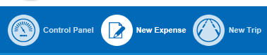

Click on New Expense:

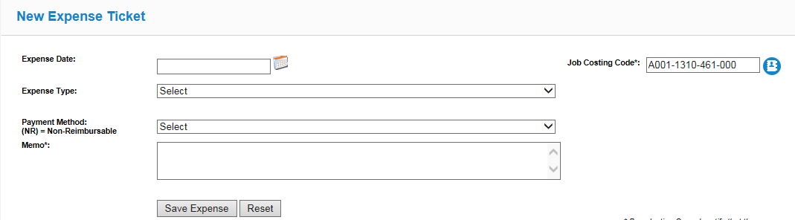

* Parking/Tolls
* Click on New Expense
* Select Expense Type

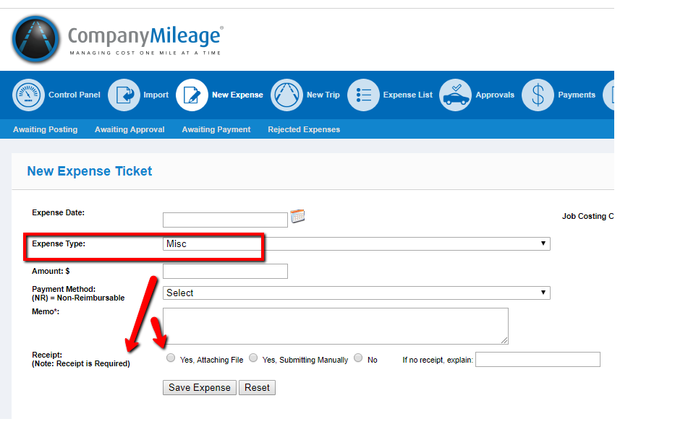

Make sure to upload your receipt or give reason why no receipt is attached.

**To enter a trip:**

**NEW TRIP**

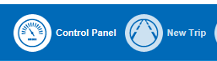

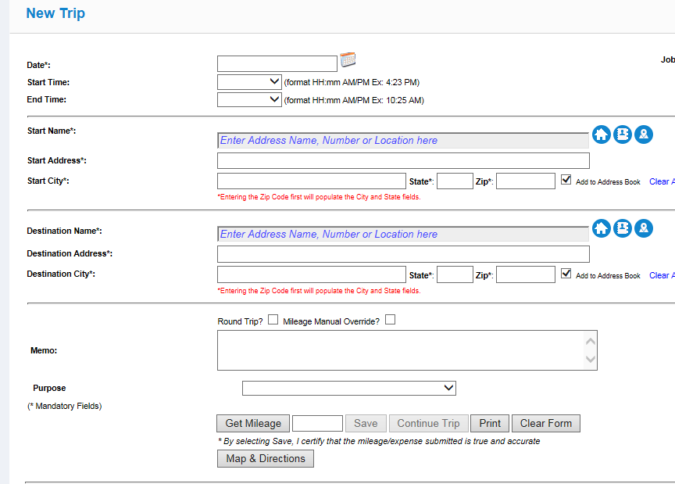

* Select Date (do not worry about Times, it is Central time and currently will not be changed)
* DO NOT change preloaded Budget code. Approver/Supervisor will change as needed.
* Click in Start Name field, start typing name of location (if using Matrix, locations will drop down)
* Type in Destination Field
* Click on Round Trip OR if Continuing on, click on Continue Trip
* Click on Get Mileage/use drop down list for Purpose. **THIS IS A MUST ENTER FIELD**.
* SAVE, or if you are heading toward your next stop, uncheck Round Trip, then Continue Trip.

**NOTES:**

* Import frequently used MATRIX addresses into your Personal Address Book (see notes on pg 5)
* Locations not on MATRIX can be added/edited and saved, you can name them (not with student’s name, initials are ok).
* **Multiple Trips to same location in one day**: you MUST place note in MEMO field “VALID DUP TRIP” or the trip(s) will be rejected.

**INPUT GRID:**

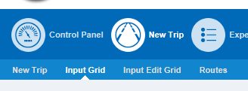

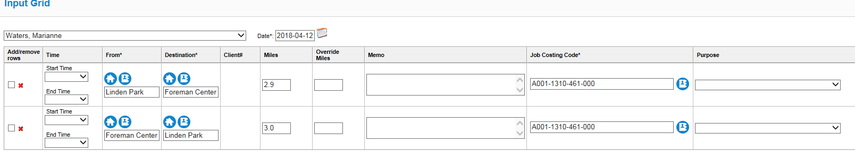

* Select Date, (do not select time, system is on Central time, see below)
* Click in From* field, then Destination, Get Mileage, enter Description of Trip, Save
* DO NOT change preloaded Budget Code. Approver/Supervisor will change as needed.
* To enter next trip, check the box in Add/Remove Rows. This will add the next trip, however: It AUTOMATICALLY fills in the Start with From of the prior line which works as your **Round Trip**.
* Click on Get Mileage/use drop down list for Purpose.
* allows a series of trips to be entered at one time (similar to hard copy) **FOR ONE DAY ONLY. YOU MUST SAVE TO START A NEW DAY.** (This works well for dates when you have multiple stops.)
* Mileage Overrides: Such as detours: **MUST ADD** regular miles and Override miles together, system calculates the payment from the Override field.
* Time stamp is currently set to CENTRAL TIME. No need to select times.
* To view the grid, click on Input Edit Grid.
* **Rejected Trips:** these are trips the Approver/Reviewer has questions on and need additional info before approving. User will receive an email notification of rejected trip:

Ex:

**From:** Company Mileage Admin <[noreply@companymileage.com](mailto:noreply@companymileage.com)>  
**Sent:** Wednesday, April 11, 2018 10:42 AM  
**To:** Que, Suzie  
**Subject:** Company Mileage: Trip Rejections

 Dear Suzie Que,  
The following trips have been rejected and need to be reviewed. These can be resubmitted, however, employee must place a MEMO in the Response Field

These can be resubmitted, however, employee must place a MEMO in the Response Field.

Once a trip is rejected, it **MUST** go through the full cycle again: User/Approver/Reviewer.

**PERSONAL ADDRESS BOOK:** Update your Personal Address by: from your Dashboard, Control Panel/Address Book/Personal

Address Book/Personal Address Book/click on Refresh List

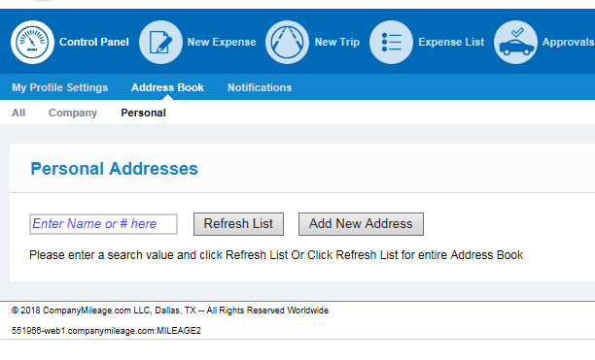

**SUREMOBILE APP:**

* Search for CompanyMileage online and select SureMobile App
* Password will be the same, has the Matrix downloaded for ease of use.
* Roundtrip is available
* When searching for location: Search Button/then start typing
* Routes: create a series of destinations, calculate the mileage and get directions
* SAVE: the input automatically is saved to your CompanyMileage account.

**REPORTS:**  Should you want to view what you have put into the system or compare what you entered to what you have been paid, go to Personal Activity Reports: enter trip date from and to and paid date.

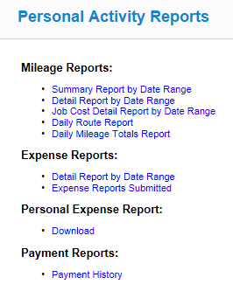

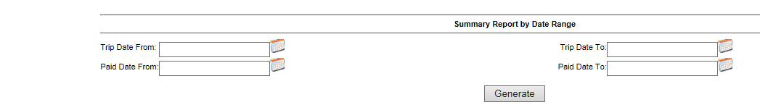

**REIMBURSEMENTS:**

ACH Dates are still the same:

Files/reimbursements will be built using end of month date, ex, OCT 2018 Mileage would be OCT 31th, paid on the NOV 15th pay date.

Reimbursements are still coordinated with payroll dates.

**Approvers DUE IN CM BY EOB REIMBURSEMENT DATE**

Mar 5, 2019 Mar 15, 2019 (Friday)

Mar 18, 2018 Mar 29, 2019 (Friday)

April 2, 2019 April 15, 2019 (Monday)

April 19, 2019 April 30, 2019 (Tuesday)