Dress Code for Work Study Program

Part of the work study program is helping to teach you positive job skills. One of those skills is wearing proper clothing at a job. You are working in the community at worksites that have expectations for their employees on how they should dress for their jobs.

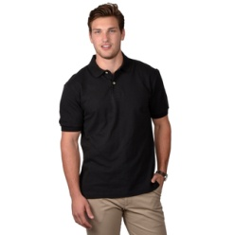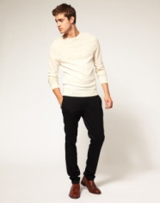Some of you have a specific uniform to wear like khaki pants and a black shirt or a white shirt and black pants.

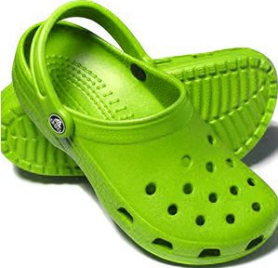All of our job sites expect you to wear closed toe shoes like sneakers. This is to keep your feet safe.

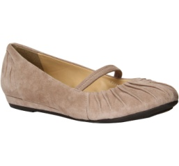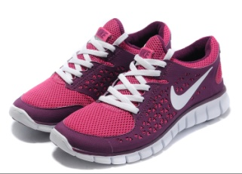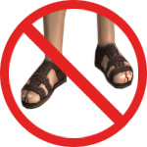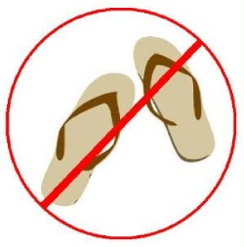

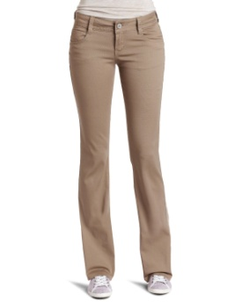All of our job sites expect you to wear pants. Jeans are allowed as long as they are clean and have no holes.

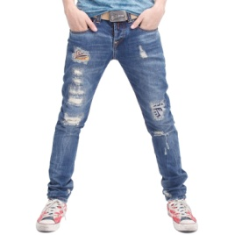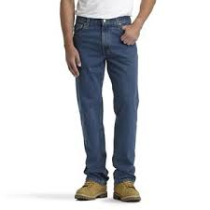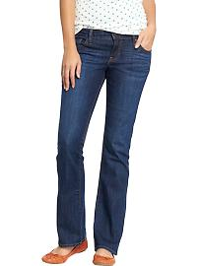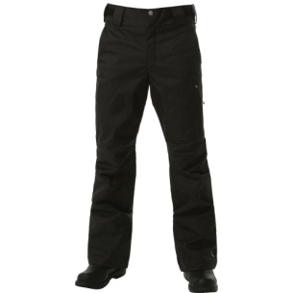

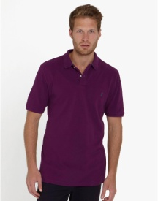No clothing should have holes, rips or tears. It should be neat and clean.

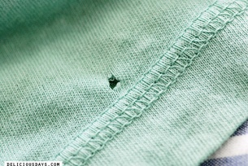

Tank tops, halter tops, spaghetti straps, low cut shirts, half shirts, shirts where your stomach is showing or see through shirts are not allowed.

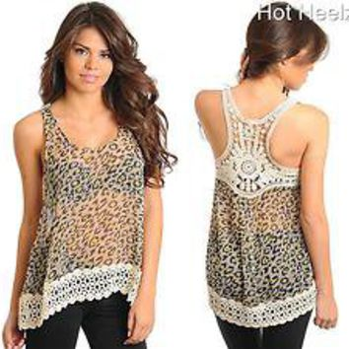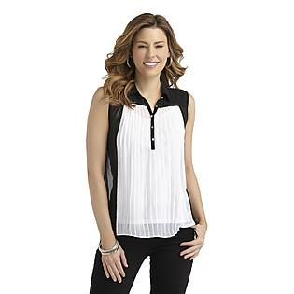

If you wear a t-shirt with a logo make sure it is appropriate for the work place.

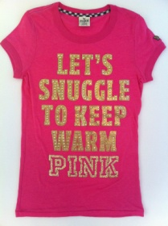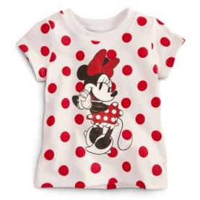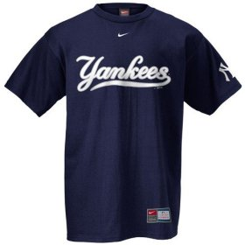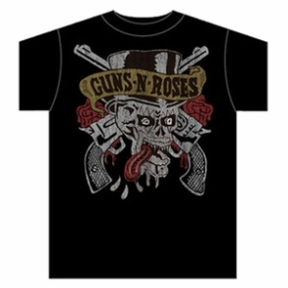

You want to make a good impression by dressing appropriately and following the dress code.

If you do not dress appropriately you will not be able to go to work.

I f you would like to bring shorts or more casual clothing to school to change into after your job that is ok.

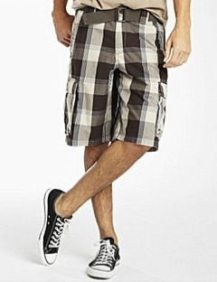

If you work in the afternoon you can bring your work clothes to school and wear more casual clothes in the morning, change into your work clothes and then back into your casual clothes.

Remember it is important to dress appropriately, be neat and practice good personal hygiene.

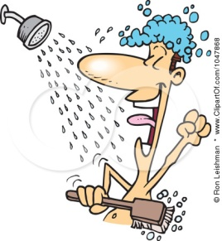

You always want to impress your supervisor and the people you will meet at your job.