Green Bean Casserole

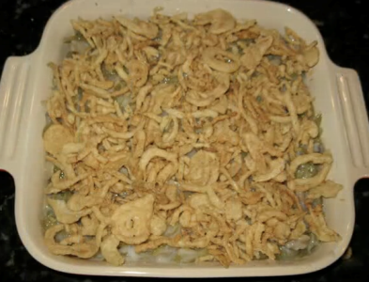Serves 6

Prep Time 10 minutes

Cook Time 35 minutes

**Ingredients**

2 packages (9oz. each) frozen French cut green beans

1 (10 ¾ oz.) can of cream of mushroom soup

¾ cup of milk

1/8 tsp. of pepper

1 1/3 cup of French Fried onions

**Directions**

1. Preheat oven to 350

2. Place beans in in bowl, cover with plastic wrap.

3. Place beans in microwave and microwave for 4 minutes or until thawed.

4. Mix soup, milk, and pepper in a 1 ½ quart baking dish. Stir in green beans and 2/3 cup French Fried onions.

5. Bake at 350 degrees for 30 minutes or until hot.

6. Stir. Top with remaining 2/3 cup French Fried onions.

7. Bake until onions are golden brown.