Name: Situation: Date:
Expected Behavior | Example (How did you show it?) | How did you feel about it? | How did others feel? | Consequence of behavior

1. RESPECTFUL

2. FOCUSED
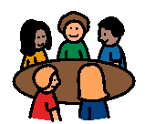

3. HONEST


4. BEST EFFORT

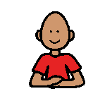
5. SELF CONTROL

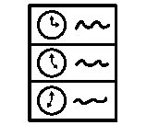
6. TIME MANAGEMENT

Expected Behavior | Examples
1. RESPECTFUL | __ 1. Be polite  __ 2. Listen to others  __ 3. Be patient  __ 4. Think of others  (Don’t be spoiled or selfish)  __ 5. Use appropriate language  __ 6. Be kind (Don’t be cruel)
2. FOCUSED | __ 1. Keep body in the group  (eyes, ears and brain in group)  __ 2. Use eye contact  __ 3. Stay alert, awake
3. HONEST | __ 1. Follow the rules, directions, laws  __ 2. Be responsible  __ 3. Be truthful, honest  (Admit you made a mistake)
4. BEST EFFORT | __ 1. Follow the rules, directions, laws  __ 2. Always look your best  (good grooming, clean clothes)  __ 3. Positive attitude
5. SELF CONTROL | __ 1. Control your actions (calm body)  __ 2. Control your emotions  (calm, appropriate language)
6. TIME MANAGEMENT | __ 1. Be punctual, on time  __ 2. Be ready for activity  __ 3. Organize and plan your time and activities

