Easy Chicken Salad

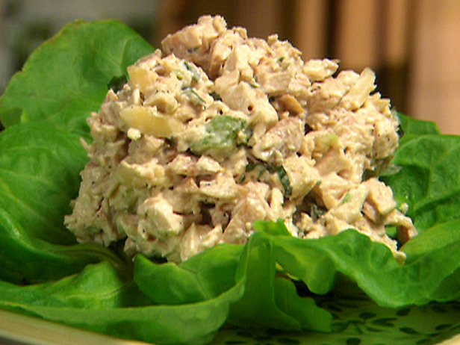
4 c. cubed, cooked chicken
1 c. sliced celery
1 c. mayonnaise
Salt, pepper, garlic powder, onion powder to taste.

Combine cooked chicken and celery. Mix together mayonnaise, Add salt, pepper, garlic powder, onion powder dressing to chicken mixture and toss gently.

