Chicken Parmesan
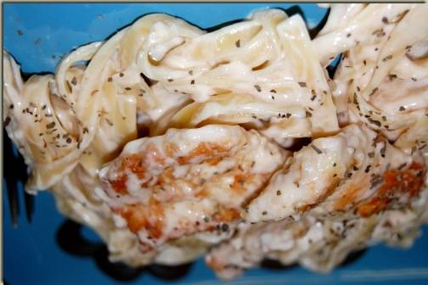
Ingredients

4 boneless, skinless chicken breasts
2 (10 ¾ ounce) cans cream of chicken soup
¾ cup grated parmesan cheese
¼-1/2 cup of water
Salt and pepper to taste
Noodles, cooked to directions on package

Directions

- Put chicken in the crockpot.
- Mix soup, cheese, salt, pepper and water in a bowl.
- Pour over the chicken.
- Put on cover.
- Cook on low for 6-8 hours or on high for 4 hours.
- Serve over cooked noodles.

